ACADEMY TERRACE HOMEOWNERS ASSOCIATION

j0155671

**2019-2020 WINTER NEWSLETTER**

**P.O. Box 64121, University Place, WA 98464**

**Website: AcademyTerraceHOA.com**

# Your Volunteer Board of Directors for 2019-2020

**Rob Ross**, President **Sharon Predoehl**, Secretary **Annie Lovell**, Board Member

**Monica Hauss**, Vice President **Tom Williams**, Board Member **Susan Peterson**, Board Member

**Roberta Runion,** Treasurer **Chris Faraca**, Board Member **Rosemarie Routson**, Board Member



**Dates to remember Neighborhood Information**

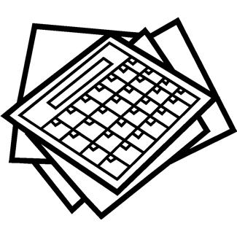

The board is considering hosting a Trunk or Treat for fall 2020, but we need volunteers! If you would like to volunteer for any ATHOA activity, please contact a board member. We appreciate our volunteers so much!

Thank you to the Curtis HS Navy ROTC for their assistance with park cleanup! Their work helped remove grass from the sand areas of the park, making it more beautiful. If you don’t yet have a key to the park, please contact the HOA Board at academyterracehoa.com/contact-us

Thank you to Susan Alexander and Loren Donahue for their service on the HOA Board! And welcome to Roberta Runion and Chris Facara!

**Add these to your calendar:**

**ATHOA Board Meeting:** Thursday, December 5th, at the home of Rob Ross (see website for address)

**University Place Winter Fest:** Friday, December 6th, 4:30-7:30pm (UP Library)

**ATHOA Spring Egg Hunt—**Saturday, April 11, 1–3pm (Community Park)

**Spring Park Cleanup –** Saturday, April 11, 3pm (Community Park)

**National Night Out—**Tuesday, August 4,   
6–8:30pm (Community Park)

**The newsletter is going paperless!**

In order to continue receiving the newsletter, please provide your email at: academyterracehoa.com/contact-us

* **Neighborhood Safety:** Neighbors have noted drivers speeding and texting while driving on Academy Terrace – please talk to your teen drivers about slowing down, there are many children in our neighborhood and safer driving can prevent a tragedy. If you see repeated speeding offenders, take pictures of the license plate and report it to the University Place Police. As always, if you see something suspicious in the neighborhood, call the University Place Police at the non-emergency line: 253-798-4722. If an immediate response is required, always call 911 instead.
* **University Place Parks & Recreation**: Seeking input for planning of current and future   
  amenities in our area. Please take the community survey to help guide our community leaders in   
  project planning and prioritization. Scan the QR code to the right or visit: https://www.surveygizmo.com/s3/5309644/UP-PROS
* **Holiday Cleanup**: Un-flocked Christmas trees can be cut to fit into your yard waste bin. The lid must be able to close for your tree to be picked up. Flocked Christmas trees must be disposed in the garbage. Plain gift wrap can be recycled, but gift wrap with foil, glitter, etc. goes in the garbage. Light strings, glass, electronics, foam packaging, and plastic bags/wrap can be dropped off at the recycle center.
* You may contact the board via the website “contact us” tool for follow-up.



December 1, 2019