ACADEMY TERRACE HOMEOWNERS ASSOCIATION

j0155671

**2020 FALL NEWSLETTER**

**P.O. Box 64121, University Place, WA 98464**

**Website: AcademyTerracehoa.com**

# Your Volunteer Board of Directors for 2019-2020

**Rob Ross**, President **Sharon Predoehl**, Secretary **Annie Lovell**, Board Member

**Monica Hauss**, Vice President **Tom Williams**, Board Member **Susan Peterson**, Board Member

**Roberta Runion,** Treasurer (**Your name could be here)** **Rosemarie Routson**, Board Member



**Dates to remember Neighborhood Information**

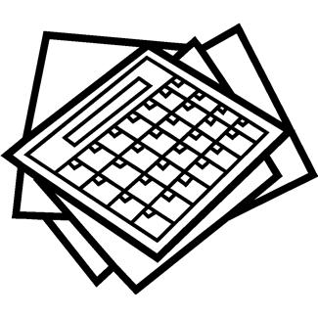

**Add these to your calendar**

**ATHOA Annual Meeting:** October 1, 2020 7:00 pm This year’s meeting will be virtual using Zoom

A link to join the Zoom meeting and the phone number to dial in will be added to the website.

We will also be adding the documents we will discuss to the website on the day of the meeting.

If you need a call-in number and don’t have access to the intranet, please call Rob Ross at 253-298-2733.

If you are interested in joining the board, we have positions open and will be voting during the Annual meeting. Contact any of the board members if you want to know more

Just a reminder that there have been several mailbox thefts in recent weeks. Make sure you bring you mail in daily. You can also sign up with the postal service for “Informed Delivery” which allows you to receive notifications via your smartphone, tablet or computer showing the mailing label of you letter sized mail pieces scheduled to arrive soon.

If you need a key for access to the park, please contact Rob Ross, Board President at 253-298-2733 or cefan82@gmail.com

**The newsletter is going paperless!**

In order to continue receiving the newsletter, please provide your email at: academyterracehoa.com/contact-us

We have only received emails for approximately half of the homeowners at this time. This will be the last

Newsletter printed and delivered. Don’t miss out! Copies of the newsletter will be available on the website.

If you don’t have email or access to a computer, contact Rob Ross at 253-298-2733 for special arrangements.

* **Neighborhood Safety:** Neighbors have noted drivers speeding and texting while driving on Academy Terrace – please talk to your teen drivers about slowing down, there are many children in our neighborhood and safer driving can prevent a tragedy. If you see repeated speeding offenders, take pictures of the license plate and report it to the University Place Police. As always, if you see something suspicious in the neighborhood, call the University Place Police at the non-emergency line: 253-798-4722. If an immediate response is required, always call 911 instead.

September 15, 2020